**Editor Mode Manual**

This manual contains some checkboxes for testing and debugging.

**Start Round**

Main -> Canvas -> Globals -> Round Manager

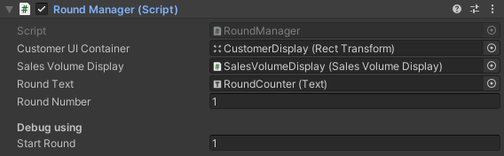

* Set game start round, able to skip all previous rounds stories

**Skip Story**

Main -> StoryManager -> Skip Story

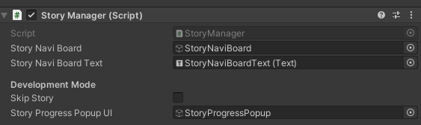

* Able to skip all stories with rewards

**Unlock all buttons**

Main -> Canvas -> Globals -> BtnController

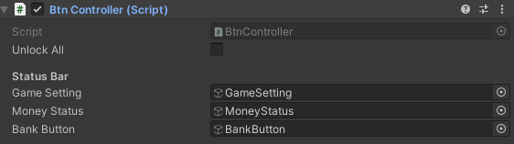

* Able to unlock inventory and budget buttons without skip story 1

**Is Save and Load**

Main -> Canvas -> Globals -> Save and Load Manager

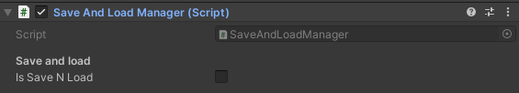

* Enable to save when the round finished and load latest saved round when game starts

**Unlock bank UI**

Main -> Canvas -> BankPanels -> SideBarPanel -> Bank UI Controller

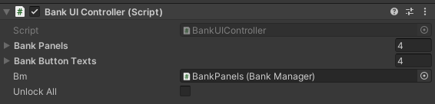

* Unlock all bank sidebar panel buttons

**[StoryAssets] Skip story**

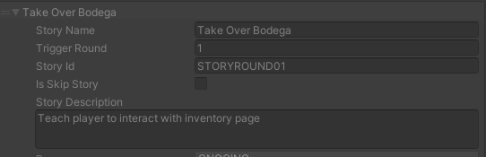

* Skip selected story

**[StoryAssets] Skip sequence**

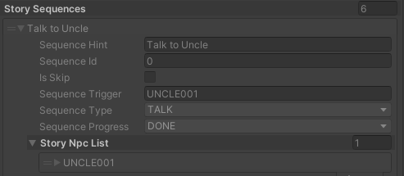

* Skip current sequence